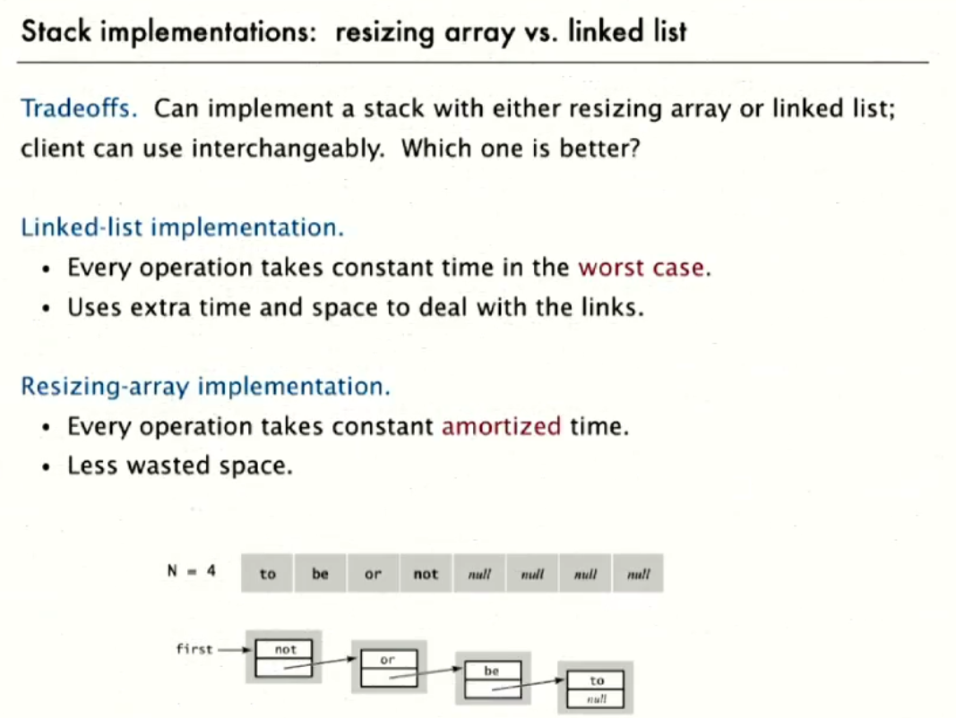

For implementing stack with array, we should use the double array resizable array implementation. This ensures the stack is an API and users don’t have to bother with the size.

For Queue, very similar theory apart from the difference in FIFO and LIFO. The operation name is enqueue and dequeue as well.

There is a 3rd type which doesn’t really bother with the order it’s called **Bag.** We can just insert items there and iterate through the bag.

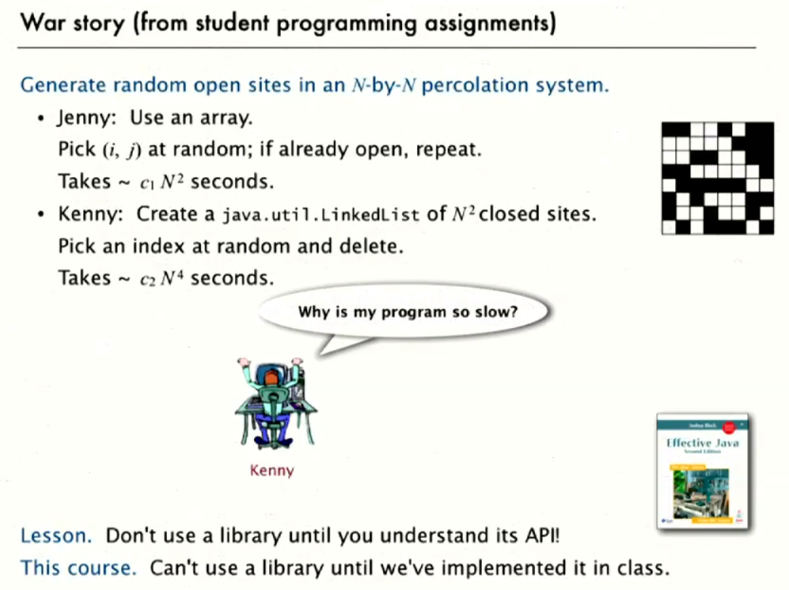

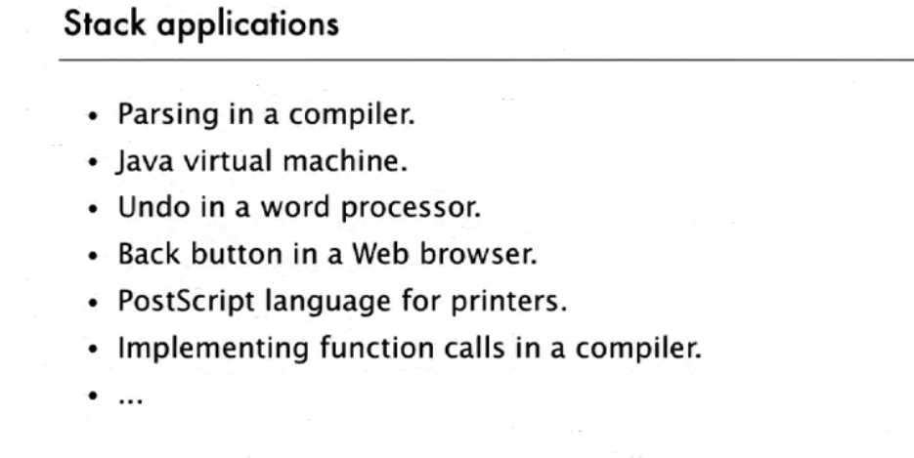

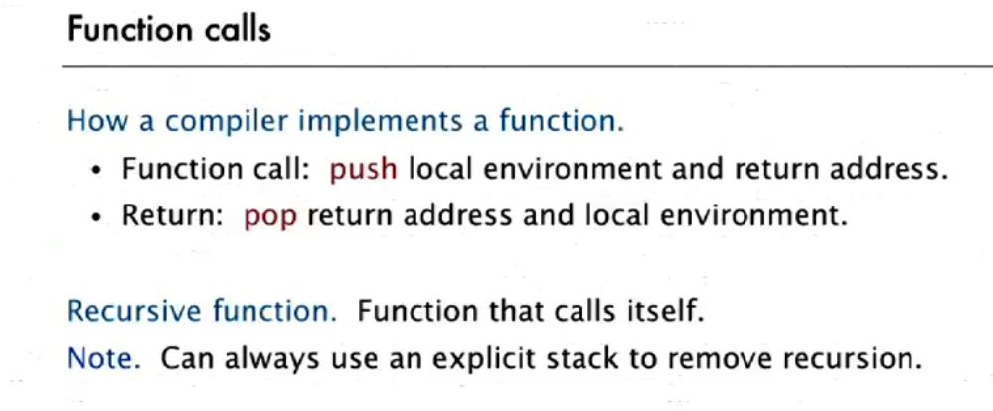

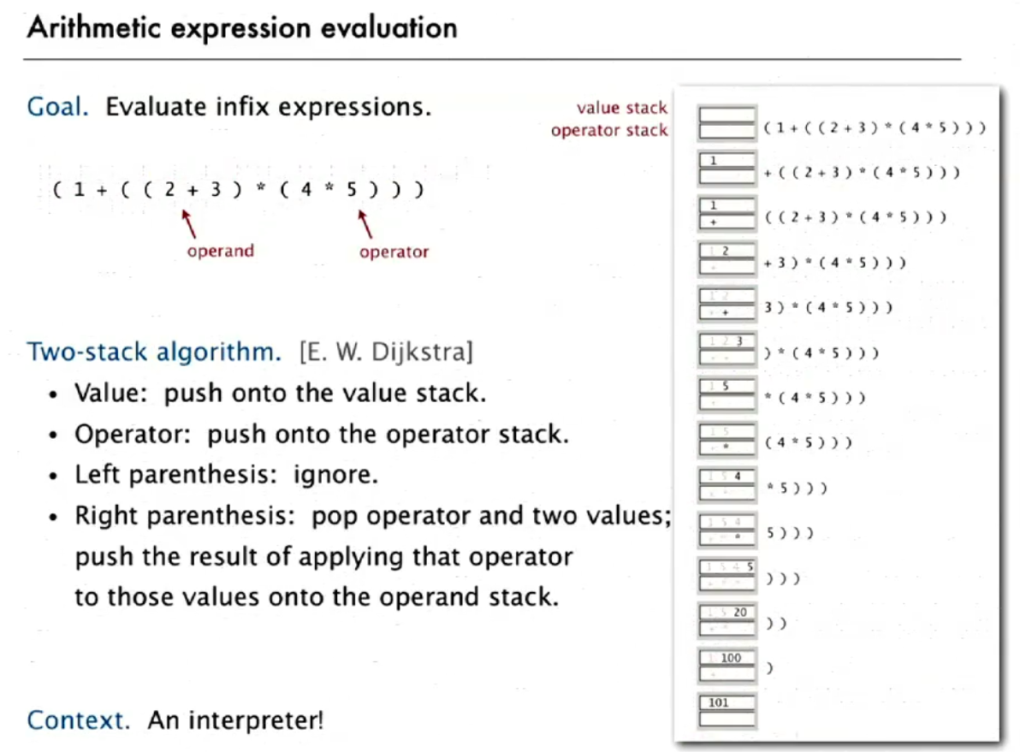

Dijkstra’s two stack algorithm for arithmetic’s expression evaluation:

